**CNM Grant Procurement Memo**

Applies to:

Funding source (choose one):

~~State~~ **Federal X**

* Federal purchases $10,000 and above or,
* State purchases $20,000 and above
* Purchases less than $60,000

**Grant/Project Title**: Dept of Ed Quantum Learning Lab

**Project Director/PI:** Brian Rashap

**Grant number within Workday**: GR300429

**Description of goods or services**: Modulated Laser

**Benefit to grant and CNM:** This Laser will allow the development of class lessons that demonstrate the wave nature of light, introduce modulation, and teach the use of oscilloscopes.

**Estimated dollar amount:** $3,472.30

**Rationale for method of procurement:** Describe how quotes were gathered

Direct quotes from three suppliers lasers

**Contractor selection or rejection:**  Name each vendor and indicate whether selected or rejected. This will document and justify the decision for procurement.

* VENDOR #1: ThorLabs
  + Selected or Rejected: **SELECTED**
  + Amount of Quote: $3,472.30
  + Justification: The ThorLabs table meets all f the technical needs and is a US-based company. The dampening needs are met at a lower price than Vendor 2.
* VENDOR #2: Edmunds
  + Selected or Rejected: Rejected
  + Amount of Quote: $6,860
  + Justification: Not Cost Competitive
* VENDOR #3: Hubner Photonics
  + Selected or Rejected: Rejected
  + Amount of Quote: $3,460
  + Justification: Non-US made laser.

**Vendor1: Thorlabs**

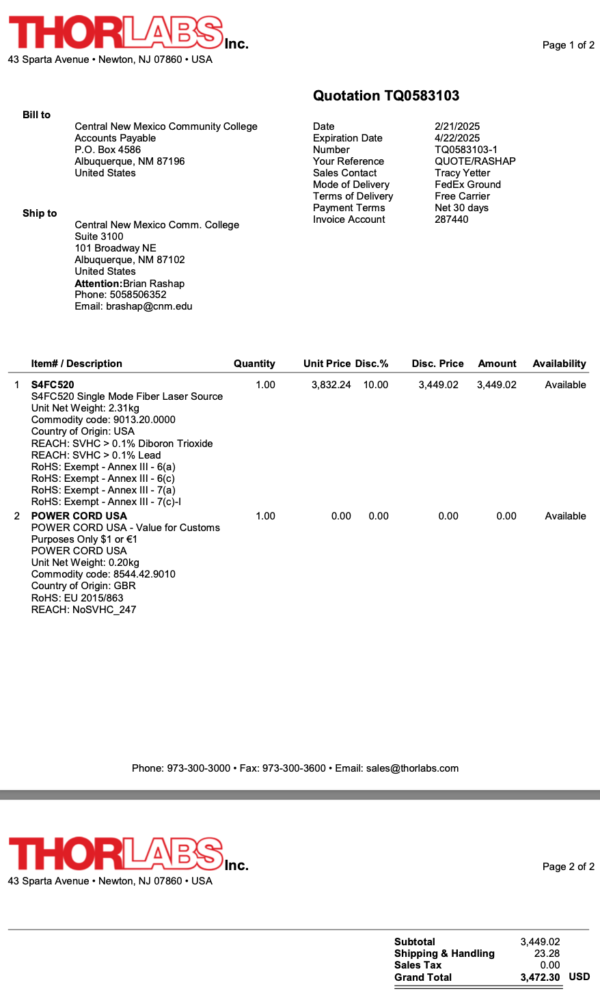

**Vendor2: Edmunds**

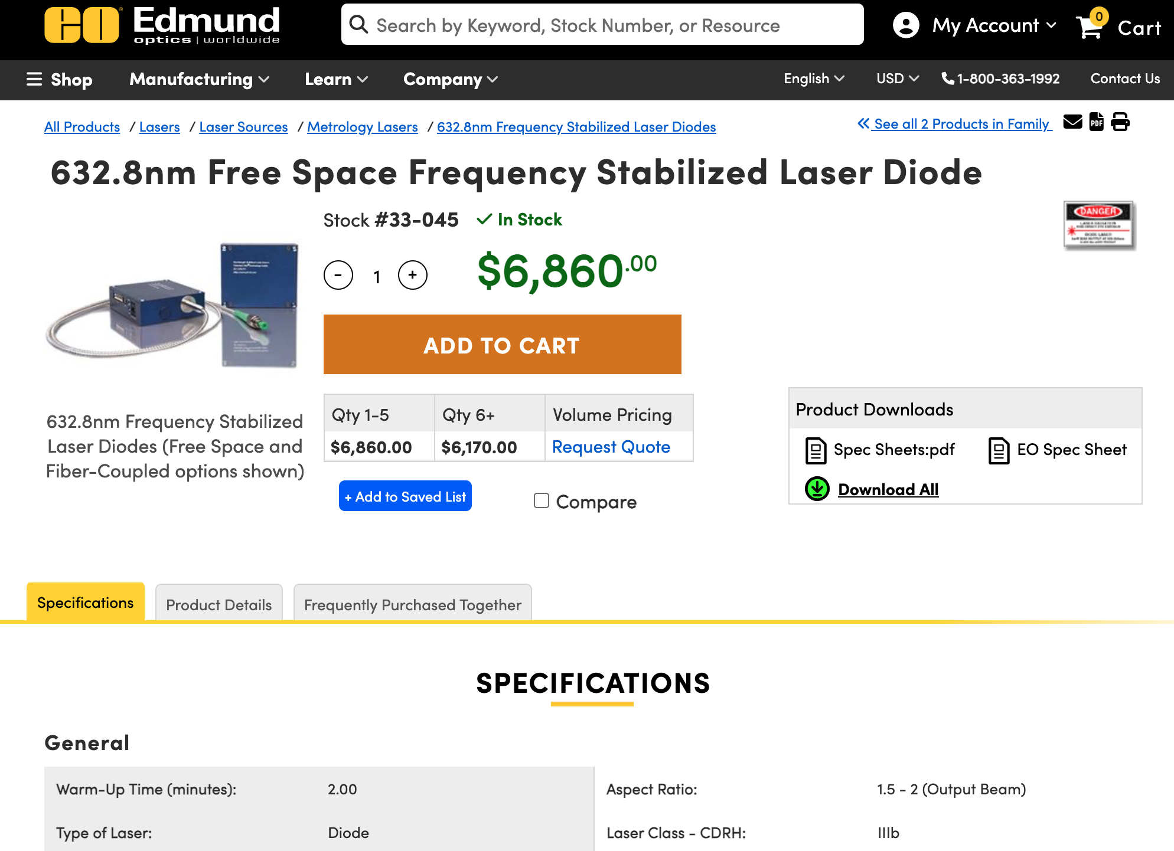

**VENDOR #3: Hubner Photonics**

